Lab 2 — Multi-Agent Orchestration with LangGraph + Azure AI Foundry

Module: A2 — Architecture & Design (Day 1)

Overview

This lab builds a production-grade multi-agent orchestration skeleton for remittance processing using LangGraph (the industry-standard stateful agent framework) and Azure AI Foundry (Azure OpenAI). By the end of this lab you will have a fully working pipeline where a Supervisor Agent routes tasks through four specialist agents — Ingestion, Remittance Processing, Payment Matching, and Smart Matching — with confidence-based escalation to a Human-in-the-Loop (HITL) review node.

Architecture

Azure AI Foundry (Azure OpenAI)
│
Supervisor Agent
│
┌───────────────┼───────────────┐
↓ ↓ ↓
Ingestion Remittance Matching
Agent Agent Agent
│ │ │
└───────────────┼───────────────┘
↓
Smart Matching
↓
HITL

┌──────────────────────────────────────────────────┐
│ │
START → SUPERVISOR ──→ INGESTION AGENT ──────────→ SUPERVISOR
│ ↑
├──→ REMITTANCE AGENT ───────────────────┤
│ │
├──→ MATCHING AGENT ─┬─ confidence≥0.85 ─┤
│ ├─ unmatched0 → SMART MATCHING ─┬→ SUPERVISOR
│ └─ else → HITL ─────────────────┤
│ │
├──→ HITL REVIEW (interrupt_before) ─────────────────┤
│ │
├──→ ERROR HANDLER ──────────────────────────────────┘
│
└──→ END (complete)

---

🛠️ Tools & Prerequisites

Software Requirements

Python | 3.10+ [python.org/downloads](https://python.org/downloads)
pip | Latest `python -m pip install --upgrade pip
Git | Latest [git-scm.com](https://git-scm.com)

Project File Structure

Lab02-MultiAgent-LangGraph-AzureAIFoundry/
├── .env.template ← Azure credentials template
├── .env ← Your actual credentials (git-ignored)
├── requirements.txt ← Pinned dependencies
├── config.py ← Azure OpenAI client factory
├── models.py ← Pydantic structured output models
├── tools.py ← Tool definitions (6 tools)
├── state.py ← Shared agent state (TypedDict)
├── agents.py ← Agent node functions (7 agents)
├── graph.py ← LangGraph orchestration graph
├── main.py ← End-to-end pipeline execution
└── validate.py ← Final validation script (8 checks)

---

Steps & Execution (End-to-End)

Step 1: Environment Setup

1.1 — Create the project directory and virtual environment

Bash
mkdir Lab02-MultiAgent-LangGraph-AzureAIFoundry
cd Lab02-MultiAgent-LangGraph-AzureAIFoundry

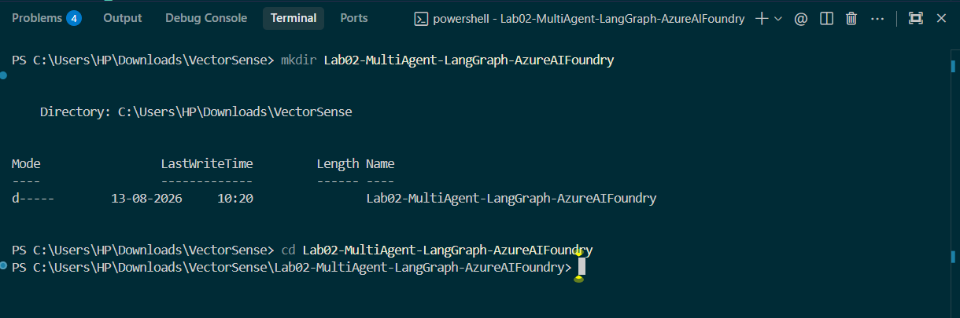

python -m venv .venv
Activate the virtual environment:
bash
Windows (PowerShell)
.\.venv\Scripts\Activate.ps1
Windows (CMD)
.\.venv\Scripts\activate.bat
macOS / Linux
source .venv/bin/activate
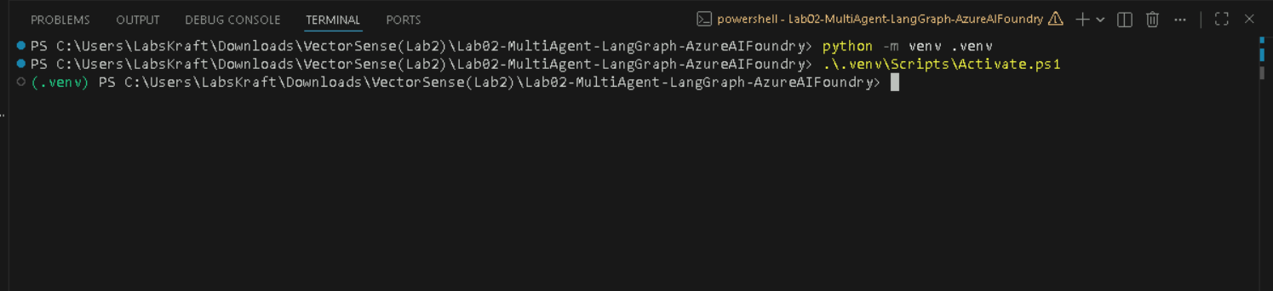

1.2 — Install dependencies

Create `requirements.txt` with the following content:
langgraph==1.2.11
langchain-openai==1.4.3
langchain-core==1.5.3
azure-identity==1.21.0
azure-ai-projects==2.0.0
python-dotenv==1.1.0
pydantic==2.11.3
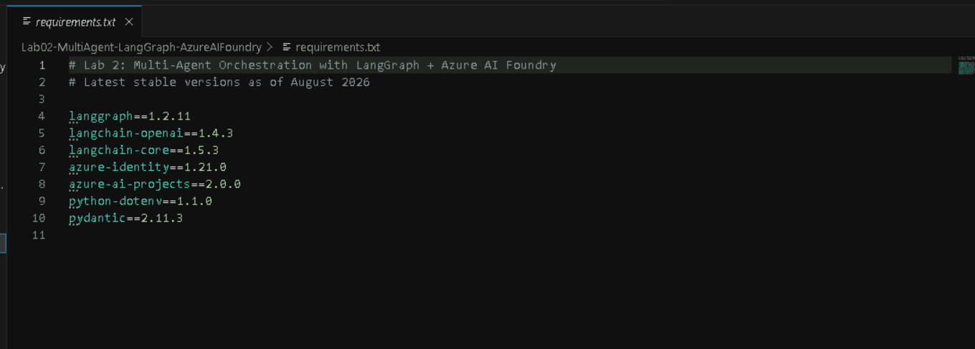

Install:
bash
python -m pip install -r requirements.txt
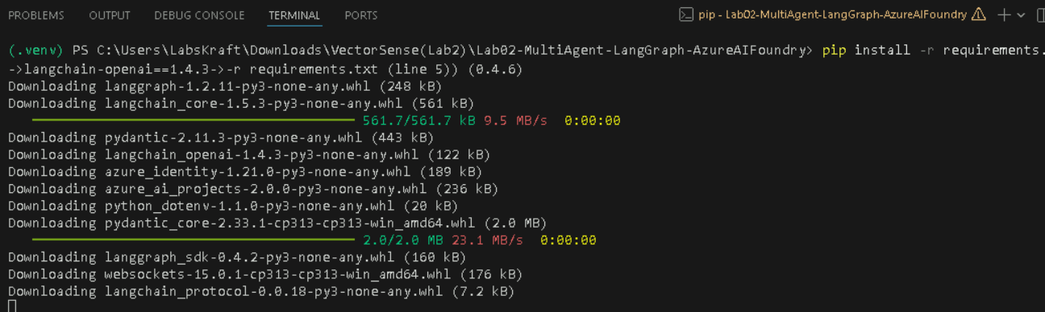

1.3 — Configure Azure credentials

Create a `.env` file from the template:

bash
cp .env.template .env

Edit `.env` with your Azure OpenAI values:

env
AZURE_OPENAI_ENDPOINT=https://<your-resource-name.openai.azure.com/
AZURE_OPENAI_API_KEY=<your-api-key
AZURE_OPENAI_DEPLOYMENT_NAME=gpt-5-mini
AZURE_OPENAI_API_VERSION=2025-04-01-preview

How to find these values:

1. Go to [Azure AI Foundry](https://ai.azure.com)
2. Open your project → Settings → Endpoints and keys
3. Copy the Endpoint and Key
4. Go to Deployments → confirm your `gpt-5-mini` deployment name
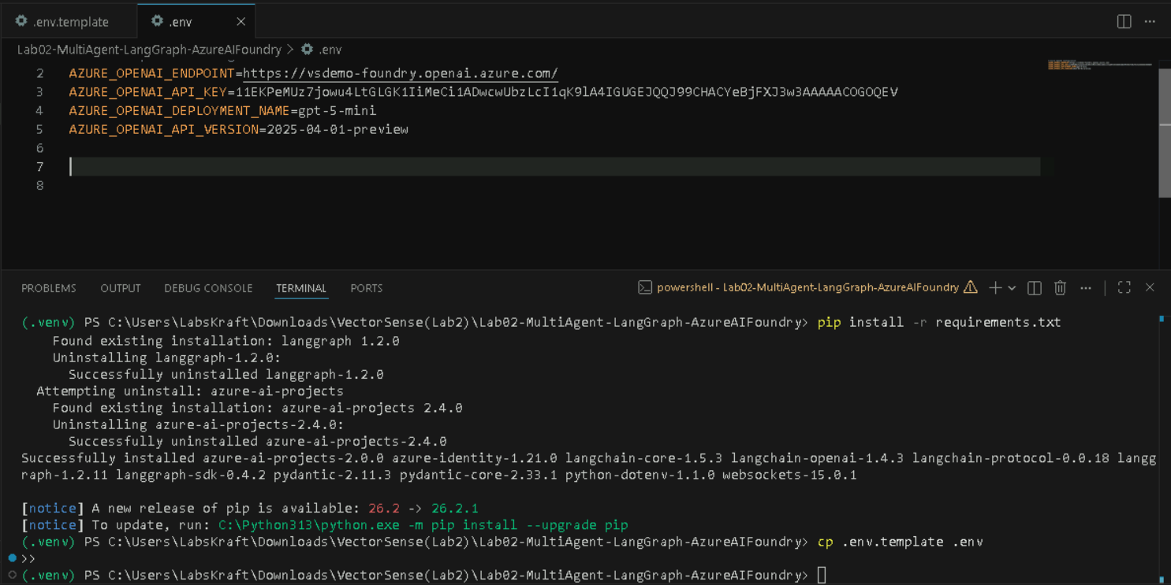

Step 2: Define Structured Output Models (Exercise: Structured Outputs)

Create `models.py` — this file defines 7 Pydantic models that enforce structured, validated outputs from every agent.
- AgentTarget: A strict list of allowed agent names for routing.
- RoutingDecision: Used by the Supervisor to output the next_agent, reasoning, and confidence score.
- RemittanceAdvice: The structured format for data extracted from the raw document (payer, amount, invoices).
- PaymentRecord: The data format for invoices pulled from the ERP system.
- MatchResult: The outcome of matching one invoice (status, variance, confidence).
- MatchingReport: A rolled-up summary of all matches, including a flag indicating if human review (requires_hitl) is needed.
- AgentOutput: A generic wrapper template used by all agents to report their status and messages consistently.

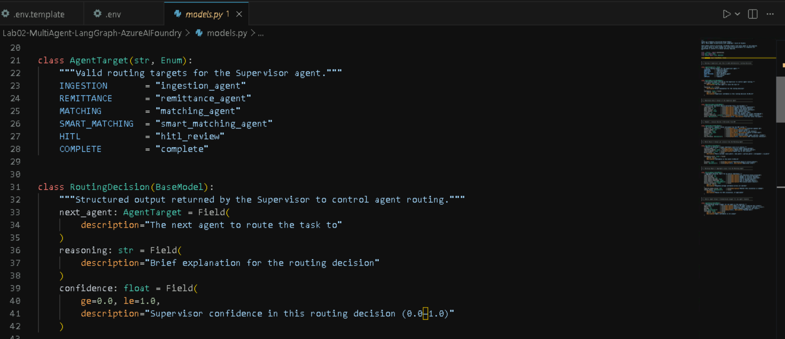
Key Design Decisions:

- Each tool has a clear docstring — the LLM uses these to decide when and how to call each tool
- Tools return dicts (not Pydantic models) for maximum compatibility with LangGraph state updates
- Simulated data mirrors real API response shapes so production swap-in is straightforward

Step 5: Build Agent Node Functions (Exercise: Agent/State Design + Tool Calling)

Create `config.py` — the Azure OpenAI client factory:

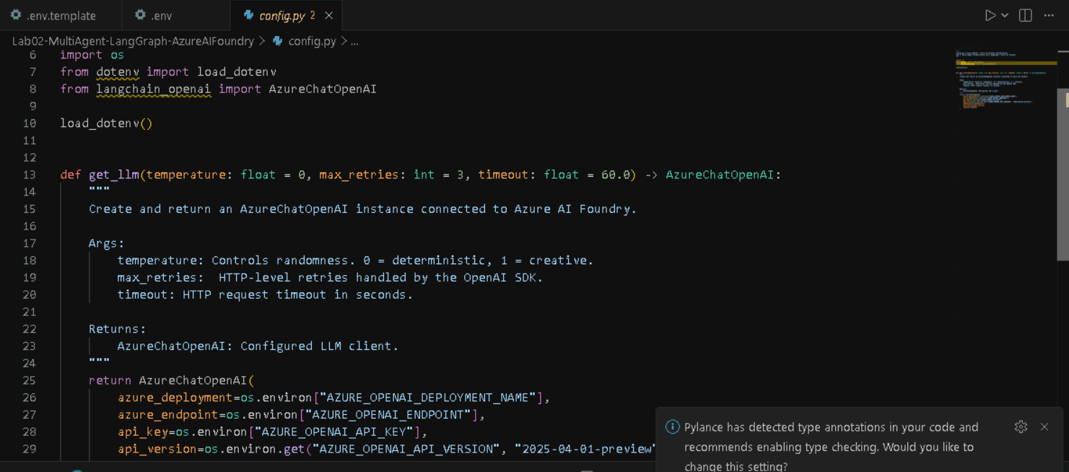

Create `agents.py` — all 7 agent nodes. Below are the key agents (see the full file for complete implementation):
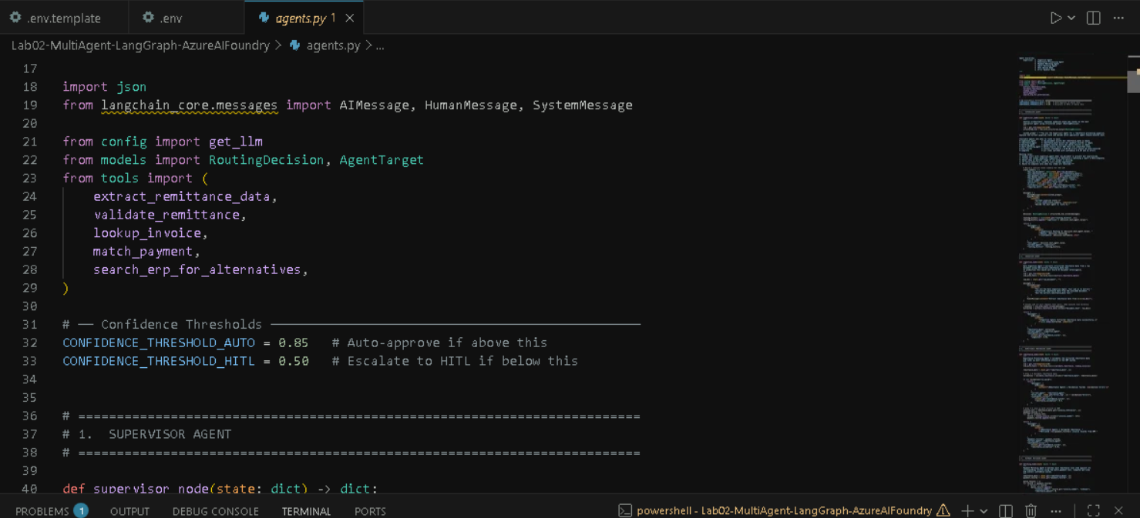

Step 6: Build the Orchestration Graph (Exercise: Agent Routing + Retry + HITL)
Create graph.py — this is where everything comes together

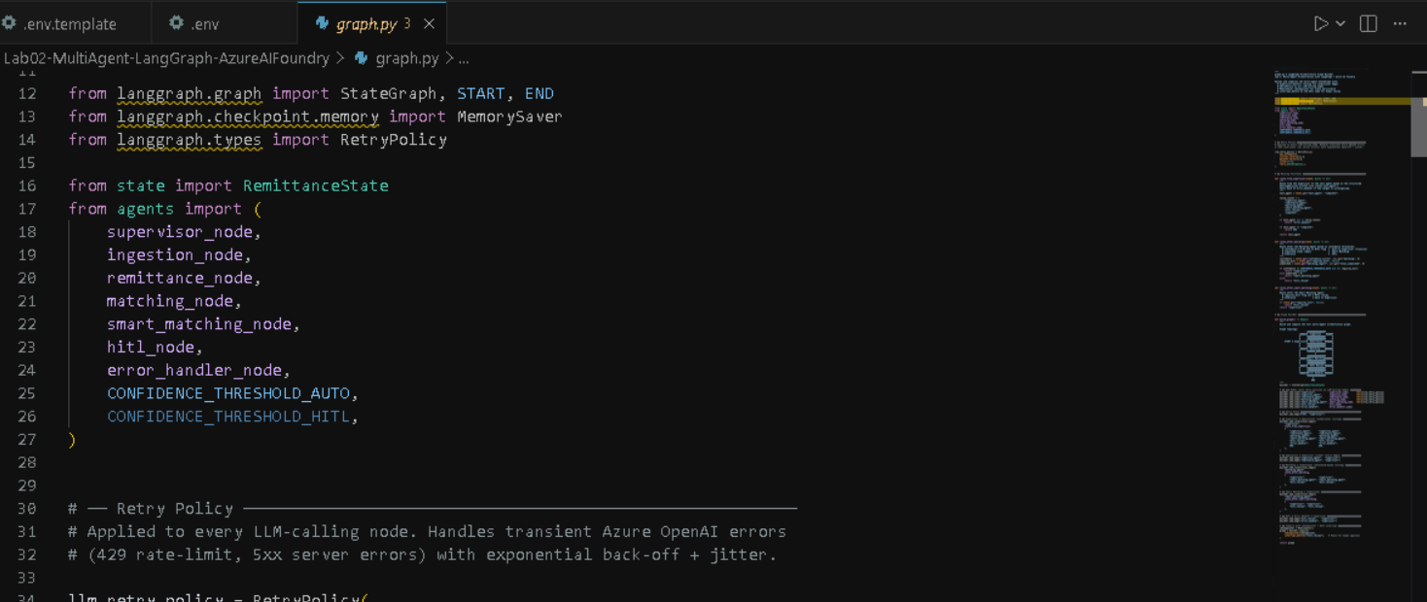
Key Design Decisions:

- `RetryPolicy(max_attempts=3, backoff_factor=2.0)` — handles Azure OpenAI 429 rate-limits and 5xx errors with 1s → 2s → 4s exponential back-off
- `interrupt_before=["hitl_review"]` — the graph pauses before entering the HITL node, giving humans time to inspect state and approve/reject
- `MemorySaver` checkpointer — persists state across the HITL pause so the graph can resume exactly where it stopped
- `route_from_supervisor` falls back to `error_handler` for unrecognised routing targets — defensive routing
- Three separate routing functions isolate decision logic per stage

Step 7: Create the Main Execution Script

Create `main.py` — runs the full pipeline end-to-end:

1. Setup & Data: Imports LangGraph modules and defines sample remittance documents (one perfect, one with errors) for testing.
2. User Input: Prompts you in the terminal to choose a test scenario: auto-approve, forced variance (reject), or custom text.
3. Initialization: Builds the graph and sets up initial_state (shared memory) alongside a thread_id (required to enable pausing/resuming).
4. Automated Run (Phase 1): Starts the workflow (graph.stream) and streams live console updates as agents process the document.
5. HITL Intervention (Phase 2): Checks if the graph paused due to a data mismatch. If paused, it asks you to type "approve" or "reject", then resumes the graph using your decision.
6. Final Output (Phase 3): Fetches the completed state and prints a final dashboard containing the routing history, agent confidence scores, and the final business logic report.

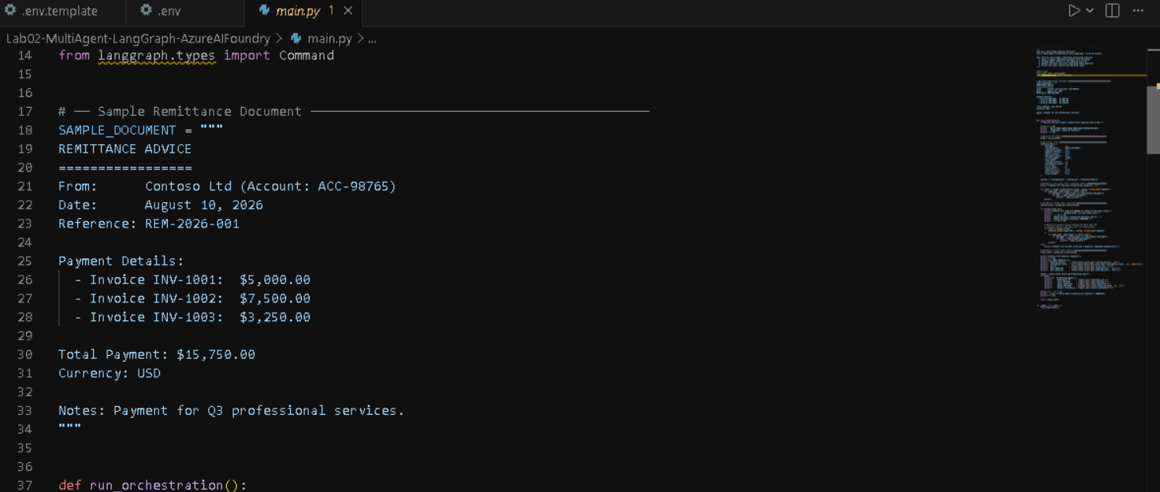

Step 8: Run the Pipeline

Execute the main script:

bash
python main.py
Choose 1,2 or 3: 1
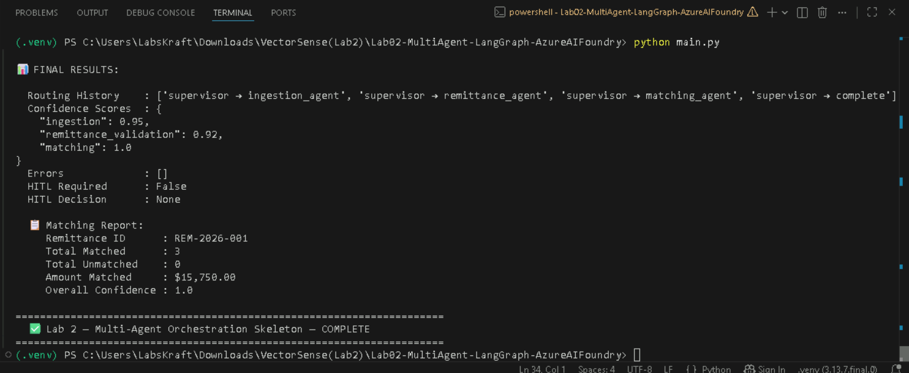

Expected Console Output:
======================================================================
MULTI-AGENT REMITTANCE PROCESSING ORCHESTRATION
LangGraph + Azure AI Foundry
======================================================================

[Phase 1/3] Starting orchestration pipeline...

[Supervisor] Routing to ingestion_agent. Reason: Raw document present, needs ingestion (confidence: 0.98)
[Ingestion Agent] Extracted remittance data successfully.
{ "remittance_id": "REM-2026-001", "payer_name": "Contoso Ltd", ... }
[Supervisor] Routing to remittance_agent. Reason: Remittance data needs validation (confidence: 0.95)
[Remittance Agent] ✓ Validated remittance. Retrieved 3 invoice records from ERP.
[Supervisor] Routing to matching_agent. Reason: Payment records ready for matching (confidence: 0.97)
[Matching Agent] Completed: 3 matched, 0 unmatched. Overall confidence: 1.00
[Supervisor] Routing to complete. Reason: All items matched with high confidence (confidence: 0.99)

[Phase 3/3] Pipeline Complete!
======================================================================

📊 FINAL RESULTS:

Routing History : [supervisor → ingestion_agent, supervisor → remittance_agent,
supervisor → matching_agent, supervisor → complete]
Confidence Scores : {"ingestion": 0.95, "remittance_validation": 0.92, "matching": 1.0}
Errors : []
HITL Required : False

📋 Matching Report:
Remittance ID : REM-2026-001
Total Matched : 3
Total Unmatched : 0
Amount Matched : $15,750.00
Overall Confidence : 1.0

======================================================================
Lab 2 — Multi-Agent Orchestration Skeleton — COMPLETE
======================================================================

Step 9: Run the Validation Script

Execute the validation to confirm all 8 exercise requirements are met:

bash
python validate.py

Expected Output:

======================================================================
VALIDATION: Lab 2 — Multi-Agent Orchestration Skeleton
======================================================================

Check 1: Package Imports
All packages imported successfully.

Check 2: State Definition
State has 15 fields — all 15 required keys present.

Check 3: Structured Output Models (Pydantic)
RoutingDecision: next_agent=ingestion_agent, confidence=0.95
MatchResult: status=exact_match, confidence=1.0

Check 4: Tool Definitions
lookup_invoice('INV-1001') → amount_due=5000.0
match_payment(5000, 5000) → exact_match (confidence=1.0)
validate_remittance → is_valid=True

Check 5: Graph Compilation
Graph compiled with 7 nodes: [error_handler, hitl_review, ingestion_agent,
matching_agent, remittance_agent, smart_matching_agent, supervisor]

Check 6: Retry & Timeout Policies
RetryPolicy: max_attempts=3, backoff_factor=2.0, initial_interval=1.0s

Check 7: Agent Routing Logic
route_from_supervisor(next='ingestion_agent') → 'ingestion_agent'
route_from_supervisor(next='complete') → END
route_from_supervisor(next='invalid') → 'error_handler'
route_after_matching(confidence=0.95, no HITL) → 'supervisor'
route_after_matching(confidence=0.40, unmatched=2) → 'smart_matching_agent'

Check 8: Confidence Thresholds
Auto-approve threshold : 0.85
HITL escalation threshold: 0.50
Correct ordering: AUTO (0.85) HITL (0.50)

======================================================================
VALIDATION SUMMARY
======================================================================

Package Imports
State Definition
Structured Outputs
Tool Definitions
Graph Compilation
Retry Policy
Agent Routing
Confidence Thresholds

Result: 8/8 checks passed

🎉 ALL VALIDATIONS PASSED — Lab 2 Complete!

======================================================================

